Scheme Description
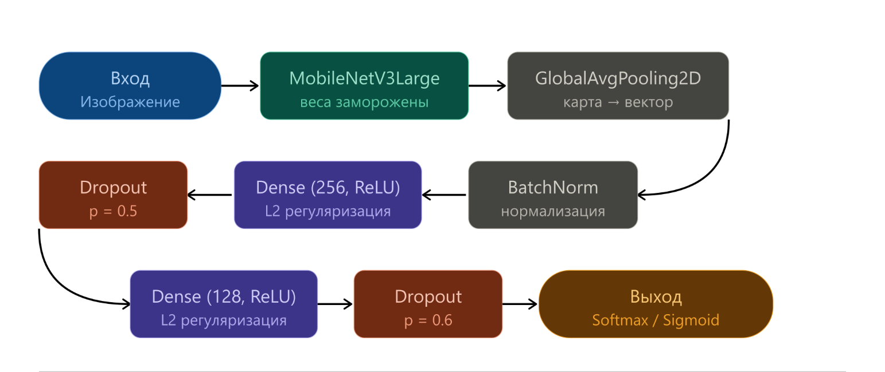
Fig. 1. Architecture of a classification neural network based on MobileNetV3Large

Figure 1 outlines the architecture of the classification network based on MobileNetV3Large. The input image first passes through the backbone, whose weights remain frozen. Global average pooling then converts the feature map into a single vector, which is normalized by a batch normalization layer. After that, the dimensionality of the representation decreases gradually: the first dense layer has 256 units, and the second one has 128. Both layers use ReLU activation and L2 regularization. Dropout follows each dense layer, and its rate rises slightly from 0.5 to 0.6, so regularization becomes stronger towards the output. Finally, the output layer produces class probabilities with softmax or sigmoid activation, depending on the classification task.

